Customizing an RC Truck for Towing and Racing

By: Joshua Danielowski, Brayden Fisher, and Andrew Vitale

January 30th, 2025

# Abstract

Table of Contents

Abstract i

List of Figures iii

List of Tables iv

Customer Needs and Requirements 1

Justification for Requirements 1

Global, Economic, Social, and Environmental Impacts 2

Design Summary (Design Iteration 1) 3

Concept Generation (Design Iteration 1) 4

Concept Selection (Design Iteration 1) 8

Detailed Design Discussion (Design Iteration 1) 13

Polymer Body 13

Tires 15

Trine “Power T” 16

Bumper 17

Trailer 19

Hitch 21

Bill of Materials 22

Manufacturing and Assembly Plan 23

Polymer Body 23

Tires 24

Trine “Power T” 25

Bumper 26

Trailer 27

Hitch 28

Testing and Validation (Design Iteration 1) 29

References 31

# List of Figures

Figure 1: Polymer Body Subsystem Concept Sketches 4

Figure 2: Headlight Subsystem Concept Sketches 5

Figure 3: Taillight Subsystem Concept Sketches 5

Figure 4: Trine School Spirit Subsystem Concept Sketch 5

Figure 5: Racing Tire Subsystem Concept Sketches 6

Figure 6: Towing Tires Subsystem Concept Sketches 6

Figure 7: Bumper and Hitches subsystem concept sketches 7

Figure 8: Trailer Subsystem Concept Sketches 8

Figure 9: Engineering Drawings for Body Components 14

Figure 10: Body Prototype 1 15

Figure 11: Engineering Drawing for Wheel 16

Figure 12: Wheel Prototype 1 16

Figure 13: Engineering Drawing for Power T 17

Figure 14: Power T Prototype 1 17

Figure 15: Engineering Drawings for Bumper Components 18

Figure 16: Bumper Iteration 1 19

Figure 17: Engineering Drawing for Trailer Components 20

Figure 18: Trailer Prototype 1 21

Figure 19: Engineering Drawing for Hitch 22

Figure 20: Hitch Prototype 1 22

Figure 21: Manufacturing Flow Chart for Body 24

Figure 22: Manufacturing Flow Chart for Tire 25

Figure 23: Manufacturing Flow Chart for Power T 26

Figure 24: Manufacturing Flow Chart for Bumper 27

Figure 25: Manufacturing Flow Chart for Trailer 28

Figure 26: Manufacturing Flow Chart for Hitch 29

# List of Tables

Table 1: Requirements for RC Truck 1

Table 2: Selection Matrix for Body Geometry 8

Table 3: Selection Matrix for Body Material 9

Table 4: Selection Matrix for Headlights 9

Table 5: Selection Matrix for Taillights 10

Table 6: Selection Matrix for Racing Tires 10

Table 7: Selection Matrix for Towing Tires 11

Table 8: Selection Matrix for Bumper Geometry Subsystem 11

Table 9: Selection Matrix for Trailer Hitch Geometry Subsystem 12

Table 10: Selection Matrix for Trailer Geometry Subsystem 12

Table 11: Selection Matrix for Trailer Material Subsystem 13

Table 12: Bill of Materials for Design Iteration 1 23

Table 13: Legend for Manufacturing Flowcharts 23

Table 14: Testing and Validation for Design Iteration 1 30

# Customer Needs and Requirements

A customer has requested that the team re-design and customize an RC truck that can excel in both racing and towing applications. The team has been asked to re-design many aspects of the RC truck which includes: a new polymer body with Trine school pride, two sets of rims and tires, one specialized for racing and the other for towing, a new aluminum bumper and hitch, a trailer which can attach to the hitch and carry a designated load, and new head and tail lights. The team is allowed $50 for purchasing materials but they must first obtain their materials from the Foundry and SDC if possible. All materials used must also be listed in the Bill of Materials. The team must make three design iterations for the product. Design Iteration 1 must be constructed using only laser-cut cardboard, cardstock, or foam board. It will be used to check dimensions, geometry, and tolerances. Design Iteration 2 can be made using both laser cutting and 3D printing to test the functionality of the prototype. Design Iteration 3 can use all manufacturing and assembly methods and will become the final product. All manufactured products must also be refined using secondary processing methods. All of these requirements can also be found in Table 1.

Table 1: Requirements for RC Truck

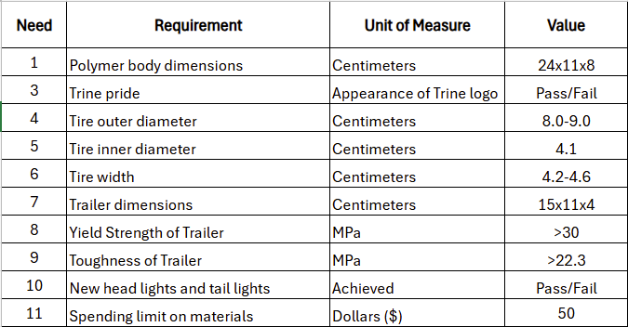

## Justification for Requirements

The RC truck must be given a new polymer body that will make it both aerodynamic and weighted evenly. It is important that the polymer body has dimensions that are compatible with the RC truck. The original body was 24 centimeters long, 11 centimeters wide, and 8 centimeters tall. The new body will have roughly these dimensions. The Trine school spirit is required because the team consists of proud Trine students. The dimensions of both sets of tires are also crucial. Based on measurements from the truck’s original tires, the new tires should have an inner diameter of about 4.1 centimeters, an outer diameter ranging from 8.0 to 9.0 centimeters, and a width ranging from 4.2 to 4.6 centimeters. The trailer should be about 15 centimeters long, 11 centimeters wide, and 4 centimeters deep. These dimensions were estimated based on the dimensions of the RC truck’s shell. Regarding the material the trailer will be composed of, it is important that it has a yield strength and toughness that will be able to support a designated load. The necessary values for each parameter were determined by comparing them to aluminum which is a suitable material for the trailer. It has also been required that the team design and manufacture new sets of headlights and taillights for the RC truck. Finally, a $50 limit for purchasing materials has been imposed on the team.

# Global, Economic, Social, and Environmental Impacts

The impacts of this project, while relatively insignificant at first glance, are quite significant when analyzed in depth. On a global scale, this project is the first step for the team in the manufacturing and engineering design process involved with the projects the team will eventually be a part of following graduation. The project helps to teach how to create concepts and select those that best fit the needs of the customer or the constraints of the project, which is one of the more difficult parts of engineering. In addition, it teaches different manufacturing processes such as casting, welding, forging, and others that we will encounter, most likely in more automated or streamlined forms, when working in industry. Furthermore, the RC industry is one that relies heavily on global supply chains, with many parts being manufactured outside of the United States and imported as a finished product or to be assembled. The trucks purchased for this project supports international trade and supply chains and provide some insight into how those processes play into our role as engineers.

The economic impact of this project will be relatively insignificant, as the entirety of the work will be done by the team, meaning that there will be no pay for anyone involved in the project. The only economic constraint provided for the project is a $50 budget, and most of the materials used will be provided by that school. The companies that produce the RC trucks used for the project will benefit from the sales, and companies that produce the raw materials used to produce the different replacement parts of the truck that the team fabricates will benefit from the sale of those raw materials. However, on a deeper look into the RC truck market, the economics are quite significant. According to Research and Markets, the RC car market grew by over USD 40 million, from USD 309.06 million in 2023 to USD 350.84 million in 2024, and is expected to reach USD 773.52 million by 2030 (Research and Markets, 2024). While this is a testament to the increase in the industry's popularity, it also spells an increase in jobs in the sectors that contribute to the RC truck industry.

The social impact of this project will be the most significant of the four categories in this section. This project will be a glimpse into the teamwork aspects that are integral to working in engineering, and it will allow the team to gain essential collaboration and teamwork skills that will allow us to thrive as engineers working in a team and collaborating with different groups within a company. The concepts of meeting deadlines, prioritizing tasks, executing them on time and with the highest quality, and delegating tasks to group members with the skills best suited for those tasks are all skills that are essential for success when working in industry as an engineer. In addition, this project could serve as the catalyst for some to further explore the RC industry, both as a hobby and as a career path. It could also awaken a preference for a larger-scale version, opening opportunities in the automotive industry for the team.

The environmental impact of this project will be relatively minimal. Most of the materials that will be used, such as aluminum for the trailer hitch or polymers and cardboard for the prototyping phases of the project, will be recycled from around The Foundry. However, there will be some trial and error throughout the prototyping process, which could lead to some plastic waste. In addition, the batteries and other electronic components of the trucks will contribute to the already prevalent issue of e-waste, where components that die often end up in landfills. One study exploring this issue defines e-waste as “a type of garbage generated by electronic in the industrial world, trash is one of the most difficult and rapidly expanding issues” (Jain et al., 2023). E-waste can harm the planet if not disposed of properly, so the electronics used during the project will need to be handled appropriately once at the end of their lifespan. There will also be a significant amount of electricity dedicated to this project, between the time spent collaborating on Teams to create the report and the time spent on school computers developing CAD files for the different components of the truck, along with the electricity required to run the machines used during the manufacturing processes. Aside from the transportation of the RC truck to The Foundry for pickup, and any other items that are ordered for the project, there will be minimal transportation costs.

# Design Summary (Design Iteration 1)

The overall design for the racing truck was divided into several subsystems, including the body geometry, body material, trailer hitch geometry, trailer hitch material, trailer geometry, trailer material, lighting components, racing wheels, and towing wheels. The team used selection matrices for each subsystem to choose the idea that best suits the customer needs from each subsystem. Each matrix utilized a 1-to-5 scale to score each concept, where 5 is the most practical and 1 is the least practical. The rows indicated the relevant qualities of each concept, and the columns contained the different design concepts. Each quality was given weight based on the team’s perceived importance to the success of the project, and the score was multiplied by the weight percentage to obtain a weighted score for each concept. The concept for each subsystem with the highest score was chosen for the team’s first design iteration. The team unanimously decided that the Trine “Power T” would be used to display school spirit. The use of subsystems allowed the team to carefully analyze each component of the truck and tailor it to fit the needs of the customer.

# Concept Generation (Design Iteration 1)

For the project, the team decided to break the product up into many different subsystems which will be developed and produced separately and brought together to make the final product. The subsystems include the polymer body, an attachment with Trine school spirit, a set of tires for racing, a set of tires for towing, a bumper with a hitch, a trailer, and head lights and taillights. For each subsystem, the team created sketches of several possible designs which allow them to be easily visualized. These sketches are preliminary, meaning that they do not include dimensions or tolerances, but they aim to give a general idea of some of the concepts the team evaluated during the first design iteration.

For the RC Truck’s polymer body, the team came up with three distinct designs. The first is a sleek model with a compact build and sharp edges. The second is a curvier design with a more intricate rear. The final design is a more stereotypical racecar build with a spoiler to reduce drag. Sketches of these designs are shown in Figure 1.

Back to the Future Concept Racecar Concept Spoiler Concept

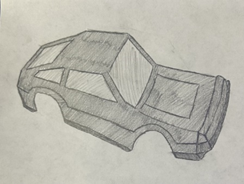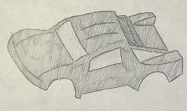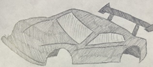

Figure 1: Polymer Body Subsystem Concept Sketches

For the head and taillights, the team has entertained a few distinct ideas that aim to add some aesthetic features to the truck. Since the lights are mainly a cosmetic feature, with a slight effect on the aerodynamics of the truck, these designs were selected and sketched to improve the appearance of the truck while also taking into consideration their aerodynamic properties (Figure 7 and Figure 8). The first design incorporates some school spirit into the design, as both the head and taillights include a section resembling a “T”. The second design resembles that of a traditional sports car, with round headlights and a sleek taillight. The third design is a more traditional truck headlight and taillight system, with a box-like appearance.

T Concept Eye Concept Boot Concept

Figure 2: Headlight Subsystem Concept Sketches

L Concept Sleek Concept Lock Concept

Figure 3: Taillight Subsystem Concept Sketches

To incorporate some Trine school spirit into the design, the team will 3D-print the Trine logo which will likely be placed somewhere on the rear end of the RC Truck to minimize the effect of the part on the truck’s speed. A sketch of the Trine T is shown in Figure 2.

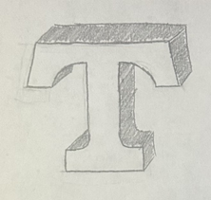

Figure 4: Trine School Spirit Subsystem Concept Sketch

For the set of racing tires, the team has narrowed it down to three similar designs. All three are wide and have minimal tread to maximize surface contact. The first design consists of a single tread through the middle of the tire with further treads branching out on either side. The second design has a more intricate tread design with several curved lines of varying lengths and a V-shape pattern. The third design has the same single tread through the middle as the first and a four-like shape repeated on each side. Sketches of these designs are shown in Figure 3.

Spiderweb Concept Antler Concept U Concept

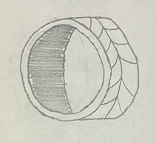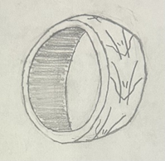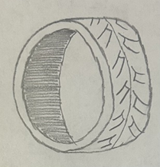

Figure 5: Racing Tire Subsystem Concept Sketches

For the set of towing tires, the team has selected three similar designs, each with some distinct different qualities that make them optimal for towing. They aim to increase friction to allow the truck to have better traction on the ground. The first design is an all-terrain style tire, which could allow for good traction and towing capabilities on the different surfaces that the truck will encounter. The second emulates a tire that would be found on a tractor or other pieces of heavy machinery, which are often designed to carry heavy objects. The third is a more traditional all-weather tire with a more aggressive tread pattern, which would allow the truck to have good traction while also not limiting its maneuverability. It is important to note that, for both the towing and racing tires, the amount of air in the tires, and the stiffness of the material used, will play a large role in the performance of the tire in both the towing and racing tasks.

Puzzle Concept Deep Concept Parallelogram Concept

Figure 6: Towing Tires Subsystem Concept Sketches

For the set of bumpers, the team sketched three designs (Figure 5). The first design is a simple, flat aluminum bumper that is easy to manufacture. The second design is like the first but is curved to be slightly more aerodynamic and more aesthetically pleasing. The third design is a curved skeletonized bumper that trades energy absorption and protection for weight. For the hitches, the team selected three designs, the first being a standard ball hitch. The second design is a hook hitch that contains no moving parts and is simple to manufacture. The third design is simply a pin which is used to connect two identical appendages that would be present on both the bumper and the trailer.

Block Concept Curved Concept Open Gate Concept

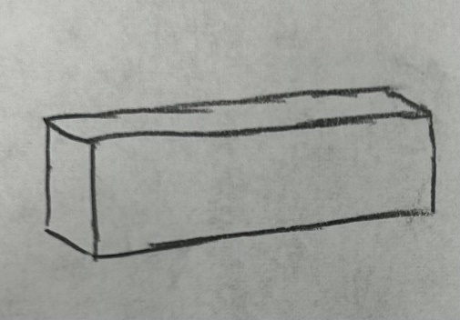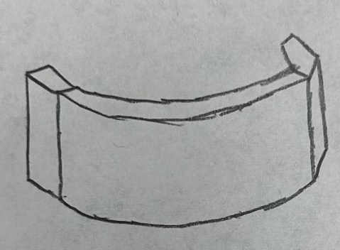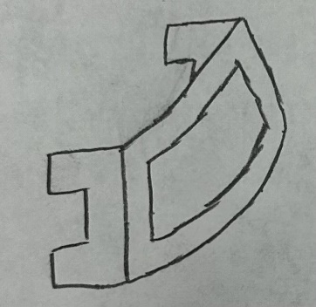

Ball Concept Hook Concept Penetration Concept

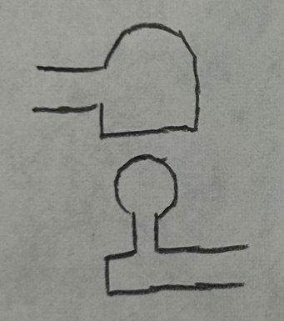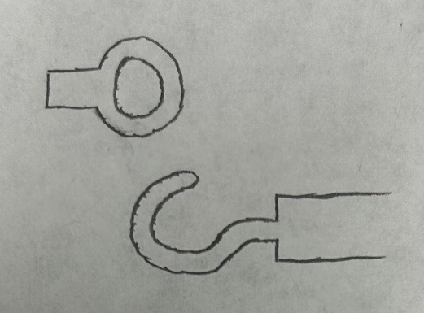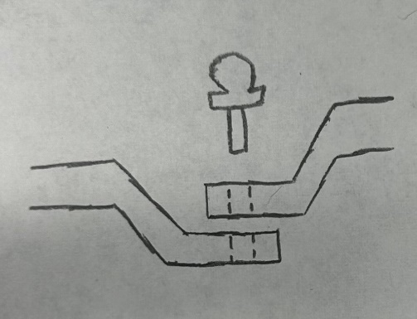

Figure 7: Bumper and Hitches subsystem concept sketches

For the set of trailers, the team sketched three similar designs (Figure 6). The flatbed trailer is long and has a low center of mass, lightweight, and able to transport varying loads. The pickup truck bed has the “trailer” integrated into the rear of the truck. This design is easy to implement into the existing shell, at the cost of bed space and load capacity. The third design is an enclosed trailer that is potentially more aerodynamic than the flatbed trailer and can protect and contain loads better. This is at the cost of potentially not being able to haul large loads due to space constraints.

Single Axle Concept Long Leg Concept Open Gate Concept

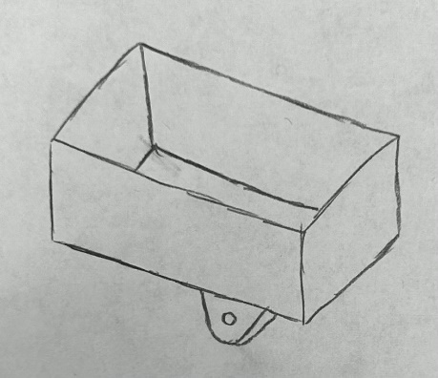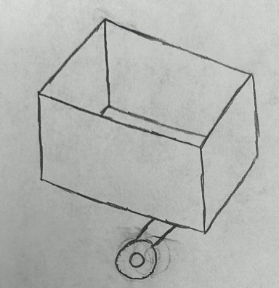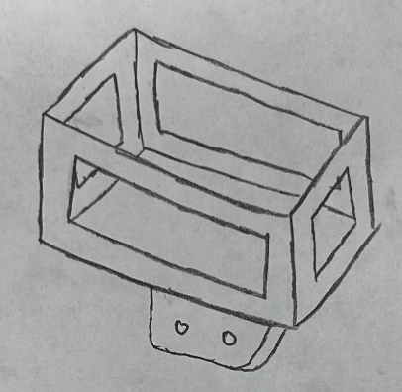

Figure 8: Trailer Subsystem Concept Sketches

# Concept Selection (Design Iteration 1)

For the body geometry subsystem, the team was tasked with deciding between three sleek designs, each of which with their own unique strengths. The team judged the models based on four categories, aerodynamics, racing, towing, and feasibility. The first, aerodynamics, is how aerodynamic each model is and how they reduce drag. The third concept was the most aerodynamic due to its racecar-like build and spoiler while the first design was the least aerodynamic due to its sharp edges. The next two categories, racing and towing, are how well each model will likely perform in the actions of racing and towing. The team decided that the third design would be best suited for racing while the second design would be best suited for towing. Finally, the team judged the feasibility of each concept, that is how realistic it is to produce each concept, which was judged to be about equal for all three. The team decided to weigh racing and towing equally at 25% each, with aerodynamics weighted at 35% and feasibility at 15%. Taking these weights into account, the team chose to pursue the third design.

Table 2: Selection Matrix for Body Geometry

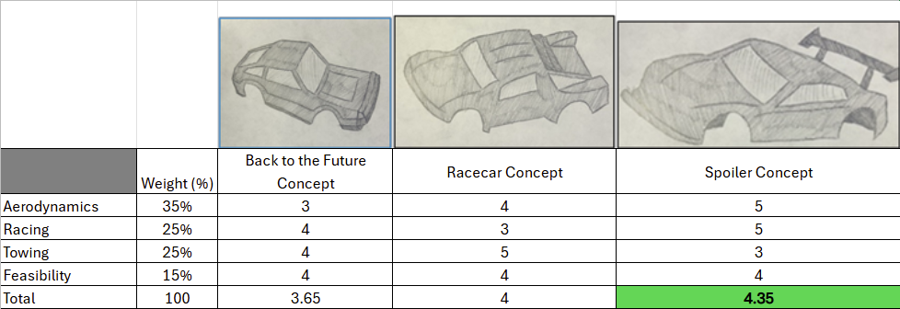

For the body material subsystem, the team decided to judge the body’s material based on durability, weight, price, and ease of production, as indicated in Table 3. The durability was scored based on the material’s ability to remain functional with excessive maintenance. Density played a large role in deciding the material that will be used for the body as it is important that the truck isn’t slowed down by a heavy shell. The final categories considered were price and ease of production, or how easily the material can be changed into its final desired shape. The team decided to move forward with polycarbonate because of its good balance of all factors.

Table 3: Selection Matrix for Body Material

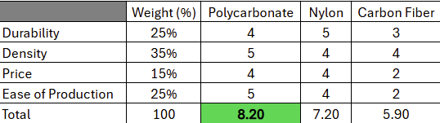

For the head and taillights subsystem, the team developed three concepts for both the headlights and taillights. The criteria used for the lights were appearance and feasibility, meaning how good they look and how logical it is to manufacture them, as indicated in Tables 4 and 5. For the headlights, the team preferred the first two concepts over the third, but the difference was made by feasibility as the first concept would be significantly more difficult to produce than the second concept. Regarding the taillights, the first two concepts certainly trump the third in terms of appearance but are far more difficult to produce than the third concept. As a result, the team decided to move forward with the third concept.

Table 4: Selection Matrix for Headlights

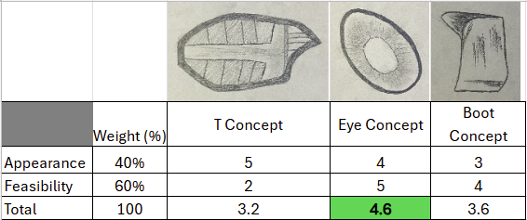

Table 5: Selection Matrix for Taillights

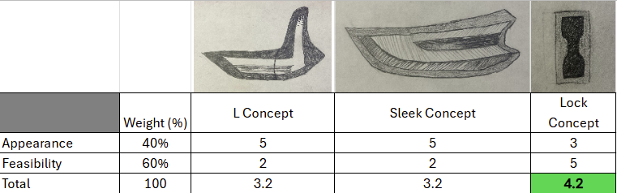

For the racing tires subsystem, the team decided to judge the models on treads and feasibility, as indicated in Table 6. The treads category is how much traction each tire will provide. For racing tires, it is ideal to have fewer and shallower treads to maximize surface contact. For this reason, along with the fact that it should be easier to produce, the first concept was chosen.

Table 6: Selection Matrix for Racing Tires

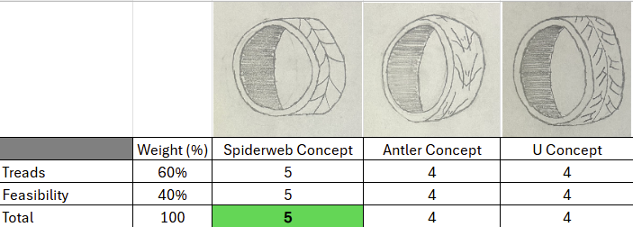

For the towing tires subsystem, the team used the same criteria as used for the racing tires subsystem. However, because the tires are designed for different applications, the treads category is slightly different. Ideal treads for towing a load are deep. The weights of each tire concept, while important, weren’t considered as a factor as these are simply concepts of a design which doesn’t consider material, size, etc. So, due to the vast depth of the treads on design two and its greater feasibility, the team decided to move forward with it (Table 7).

Table 7: Selection Matrix for Towing Tires

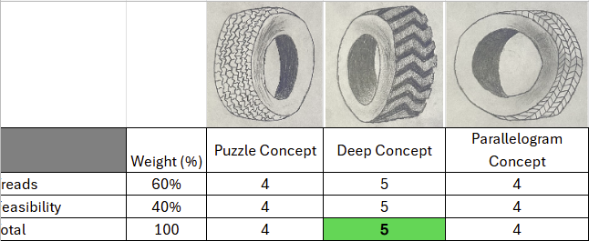

For the aluminum bumper geometry subsystem, the team decided to judge the concepts based on weight distribution, volume, and feasibility, as indicated in Table 8. The weight distribution section was judged on how much the bumper would affect the center of mass for the vehicle, which was the same for all three concepts. The volume section was judged based on how little volume it took up. The third and final was feasibility, this was judged on how easily this would be to manufacture. Feasibility was weighted the highest, so the team decided to proceed with concept number three.

Table 8: Selection Matrix for Bumper Geometry Subsystem

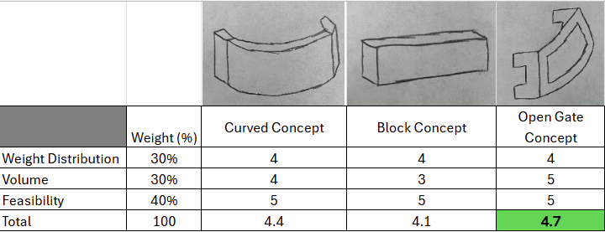

For the trailer hitch geometry subsystem, the team judged the hitch geometries based on feasibility, simplicity, and strength, as indicated in Table 9. The feasibility section was scored on how easy it would be to manufacture. Connectivity is how well each hitch connects the bumper and trailer. Strength was scored based on how well each hitch would handle vibrations and stresses caused by the load on the trailer. Since strength was the most important feature of the design, the team decided to proceed with concept two due to its greater strength.

Table 9: Selection Matrix for Trailer Hitch Geometry Subsystem

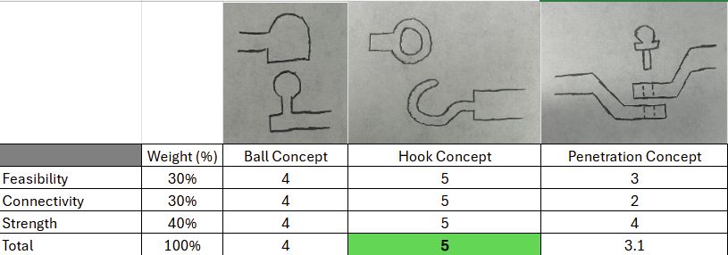

For the trailer geometry subsystem, the team decided to judge the hitch geometry based on stability, feasibility, capacity, and strength, as indicated in Table 10. Stability was judged on how stable the designated load would be when moving and vibrating. Feasibility was judged on ease of manufacturing of the trailer. Capacity was judged by how large a load it could carry, and strength was judged on how much weight the trailer could withstand, which will also be highly reliant on the material chosen. Since capacity was the greatest factor in the design, the team decided to proceed with concept one.

Table 10: Selection Matrix for Trailer Geometry Subsystem

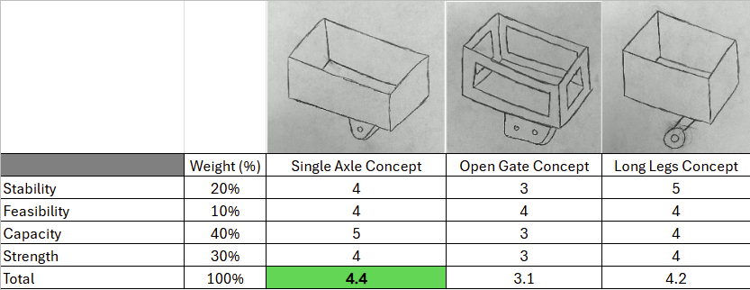

For the trailer material subsystem, the team decided to judge the trailer material on durability, weight, price, and ease of production, as indicated in Table 11. The durability was scored based on the material’s resistance to scratches, deformation, and cracking. The weight category was scored based on the material’s weight. The price category was scored based on ease of production, or how easily the material is to change into its final desired shape. The team decided to move forward with aluminum because of its good balance of all factors.

Table 11: Selection Matrix for Trailer Material Subsystem

# Detailed Design Discussion (Design Iteration 1)

This section outlines the process of designing the prototype for each subsystem for design iteration one. This section also includes the bill of materials for the first design iteration and the testing and validation of the initial prototype from each subsystem.

## Polymer Body

The body concept chosen for the car aims to optimize both the towing and racing abilities of the truck. With a spoiler to reduce drag and lift, the team designed this body concept to have the appearance of a race car, with the necessary aerodynamic properties to excel at racing. The rough dimensions for the body were taken using digital calipers and rough sketches were drawn on paper before transferring them into CAD. For the first design iteration, the body panels of the truck were cut using the laser cutter and glued together with hot glue. The body was drawn in CAD, and additional part files were drawn for the top and side panels of the car. The body panel files were saved as a DXF file and then transferred to the laser table for cutting. The engineering drawings for the first iteration are shown in Figure 9.

After the files were transferred, the team placed a sheet of cardboard on the laser table and cut out the top and side panels of the body. Since the manufacturing methods available for design iteration 1 did not allow the team to express the full detail for the body concept, the first design iteration was used to ensure that the dimensions of the body fit the car without impeding the wheels of the car, and that the wheel wells fit the dimensions of the chassis. The shell is shown in Figure 10.

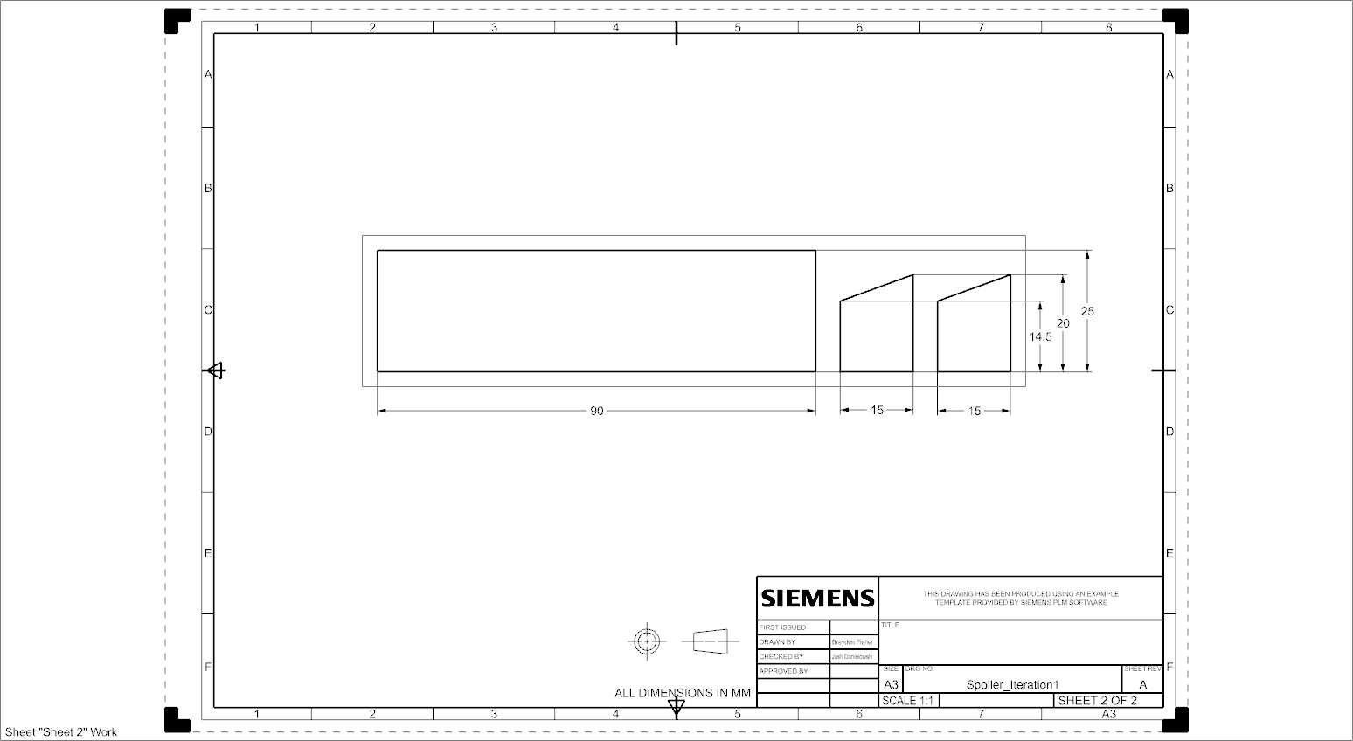

Figure 9: Engineering Drawings for Body Components

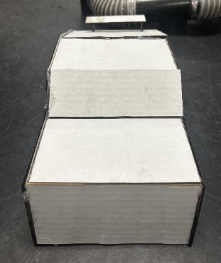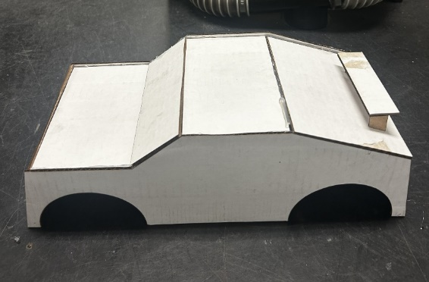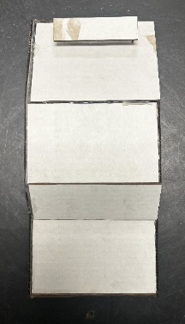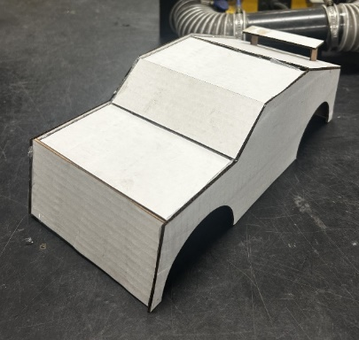

Figure 10: Body Prototype 1

## Tires

The first iteration of the tire, shown in Figure 12, was chosen because of its tread patterns for their designated job. While one was chosen for racing and the other for towing, both would have the same fitting on the truck, and so only one prototype was manufactured to ensure the correct fit with the axle of the truck. The tires were drawn in CAD using dimensions obtained using calipers. The engineering drawings for the tire are shown in Figure 11. Those CAD files were converted to DXF files and sent to the laser table for cutting. The goal of the first iteration was to confirm that the axle fit snugly into the tire and that the hexagon cutout on the axle fit into the new tire design to ensure the new tire fit well and did not slip. Given the manufacturing processes available for design iteration 1, the team did not feel it necessary to create a 3-D tire in order to save on material costs. With the dimensions for the axle and hexagon cutout confirmed, future iterations will include treads made from rubber and a 3-D printed rim.

Figure 11: Engineering Drawing for Wheel

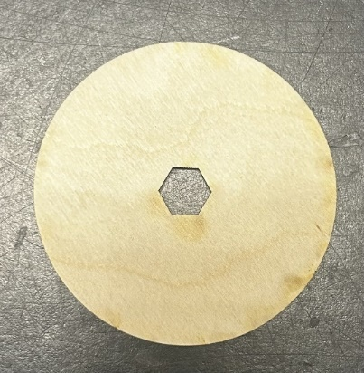

Figure 12: Wheel Prototype 1

## Trine “Power T”

The Trine “T”, shown in Figure 14, was laser cut using cardboard for design iteration 1 to ensure dimensions would fit on the roof of the body. Since the component is purely cosmetic, the goal of the first design iteration was to assess the dimensions. The dimensions were taken using a ruler and drawn in CAD. The CAD file was then saved as a DXF file and transferred to the laser table for cutting. The engineering drawings for the Power T are shown in Figure 13. The final iteration will be cast from aluminum, ensuring that the final design adds a bit of weight to allow better traction from the tires, but not so heavy that it weighs down the truck.

Figure 13: Engineering Drawing for Power T

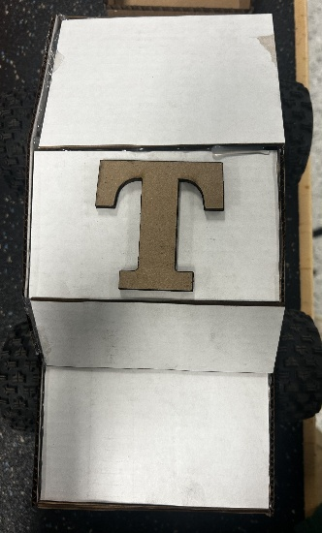

Figure 14: Power T Prototype 1

## Bumper

The design for the bumper, shown in figure 16, was chosen due to its similar qualities to a standard bumper and lesser mass. The design is a simple rounded bumper with a rectangular cutout and a further attachment at the bottom, which will allow it to be attached to the RC truck the same way the original bumper was. The dimensions of an ideal bumper were taken using calipers and were transferred onto rough sketches, which allowed the bumper to be easily drawn in CAD. For the first design iteration, due to the limitation that only cardboard is allowed, the team simplified the design to make it easily made in 2D. This iteration of the bumper consists of a flat rectangular base and the same rectangular cutout in the center of the base. The rectangular piece used to attach the bumper to the RC truck is the same. The CAD files were then saved as DXF files and transferred to the laser table for cutting. These engineering drawings are shown in Figure 15. The bumper was cut into two separate parts, the bottom, which will attach to the truck, and the vertical piece that will protect the chassis of the truck. The final design for the bumper will be made from cast aluminum, which will add a bit of weight to the rear of the truck and support the weight of the trailer and road, but not so much as to weigh the truck down.

Figure 15: Engineering Drawings for Bumper Components

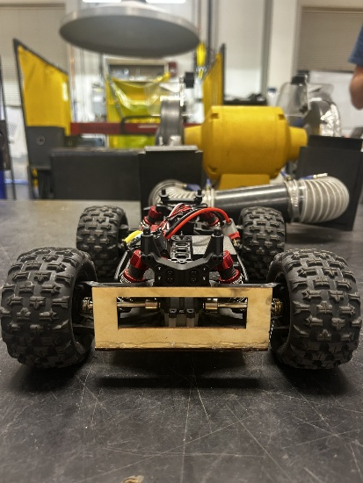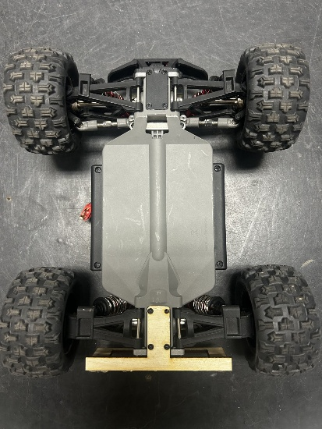

Figure 16: Bumper Iteration 1

## Trailer

The design for the trailer, shown in Figure 18, was chosen due to its ability to support the designated weight and to easily attach to the trailer. The dimensions of the trailer were taken with respect to the truck itself, using a slightly smaller width and length than the truck chassis. These dimensions were taken using a ruler and transferred onto rough sketches, which were then transformed into CAD parts. Similarly, the hook was drawn in two dimensions with respect to the dimensions of the loop that will be attached to the bumper. These measurements were taken using calipers, which were transferred onto rough sketches and then drawn in CAD. The CAD files were saved as DXF files and transferred to the laser table for manufacturing. These engineering drawings are shown in Figure 17. Due to the manufacturing processes available for the first iteration, the five sides of the trailer were each drawn as separate rectangles and cut from the same piece of cardboard. The pieces were then assembled using tape and hot glue to achieve the final geometry of the trailer. The final iteration will be made from cast aluminum to both support the weight of the load and to meet the stress requirement set by the team.

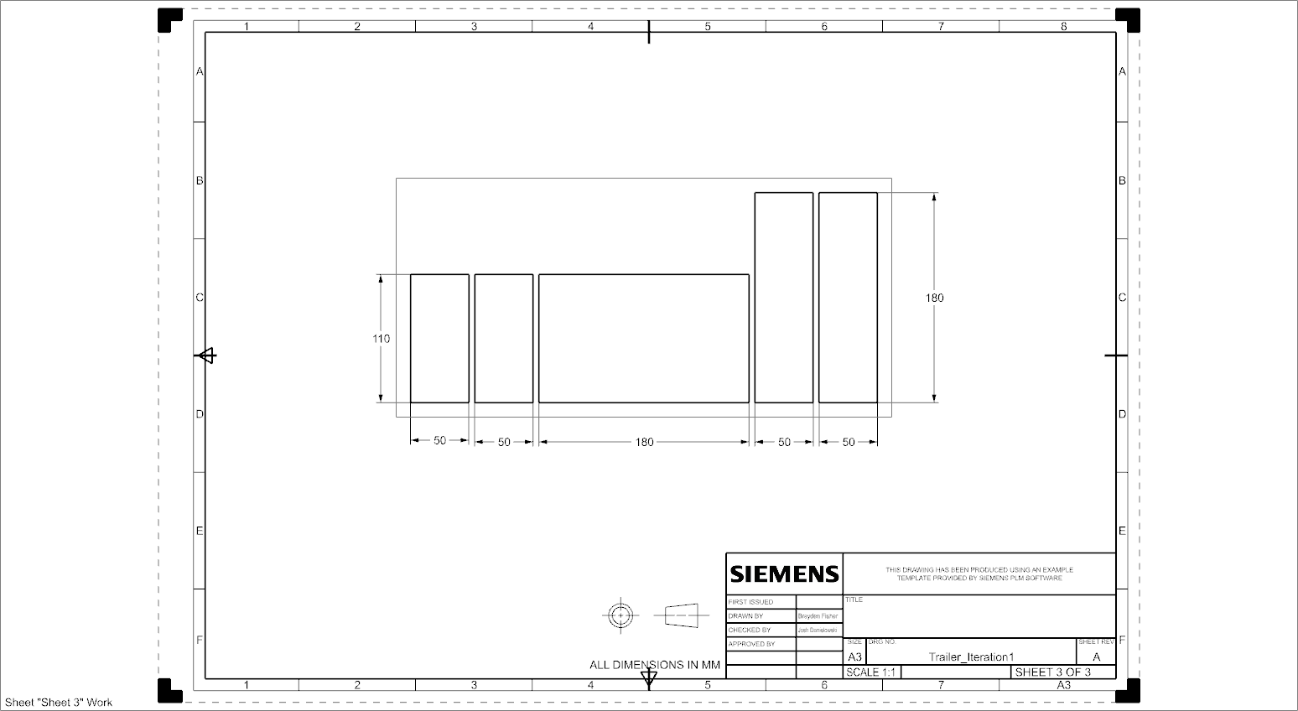

Figure 17: Engineering Drawing for Trailer Components

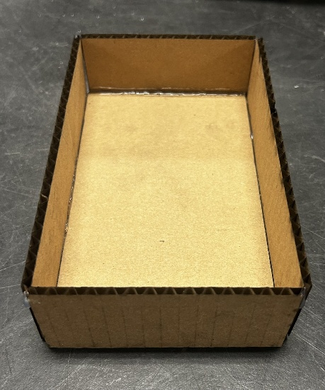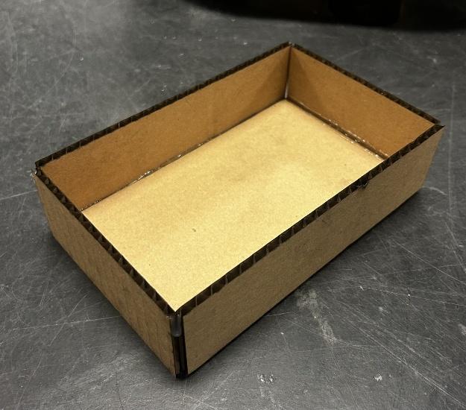

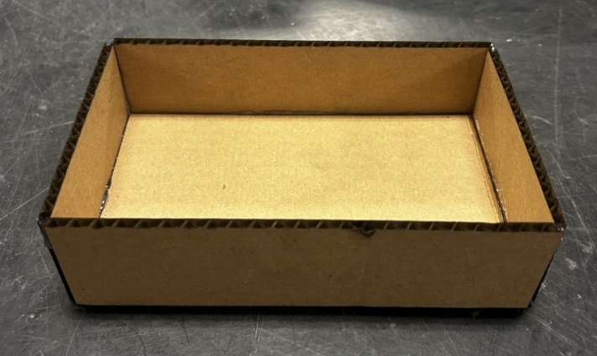

Figure 18: Trailer Prototype 1

## Hitch

The hitch, shown in Figure 20, was chosen due to its secure latching design that would ensure the trailer would stay securely connected to the truck. The design utilizes a hook and loop mechanism to allow the trailer to be securely attached to the rear bumper of the truck. The measurements for the hitch mechanisms were found with respect to the body, bumper, and trailer dimensions and were taken using calipers. The dimensions were recorded on paper in the form of rough sketches, then transferred to CAD software. The engineering drawings for the hitch are shown in Figure 19. The CAD files were then exported as DXF files and transferred to the laser table for cutting. The hitch was cut from basswood and used primarily to test the fitment of the pieces together. In future iterations, the loop will be connected to the rear bumper made of aluminum, and the hook will be a part of the trailer, also made of aluminum.

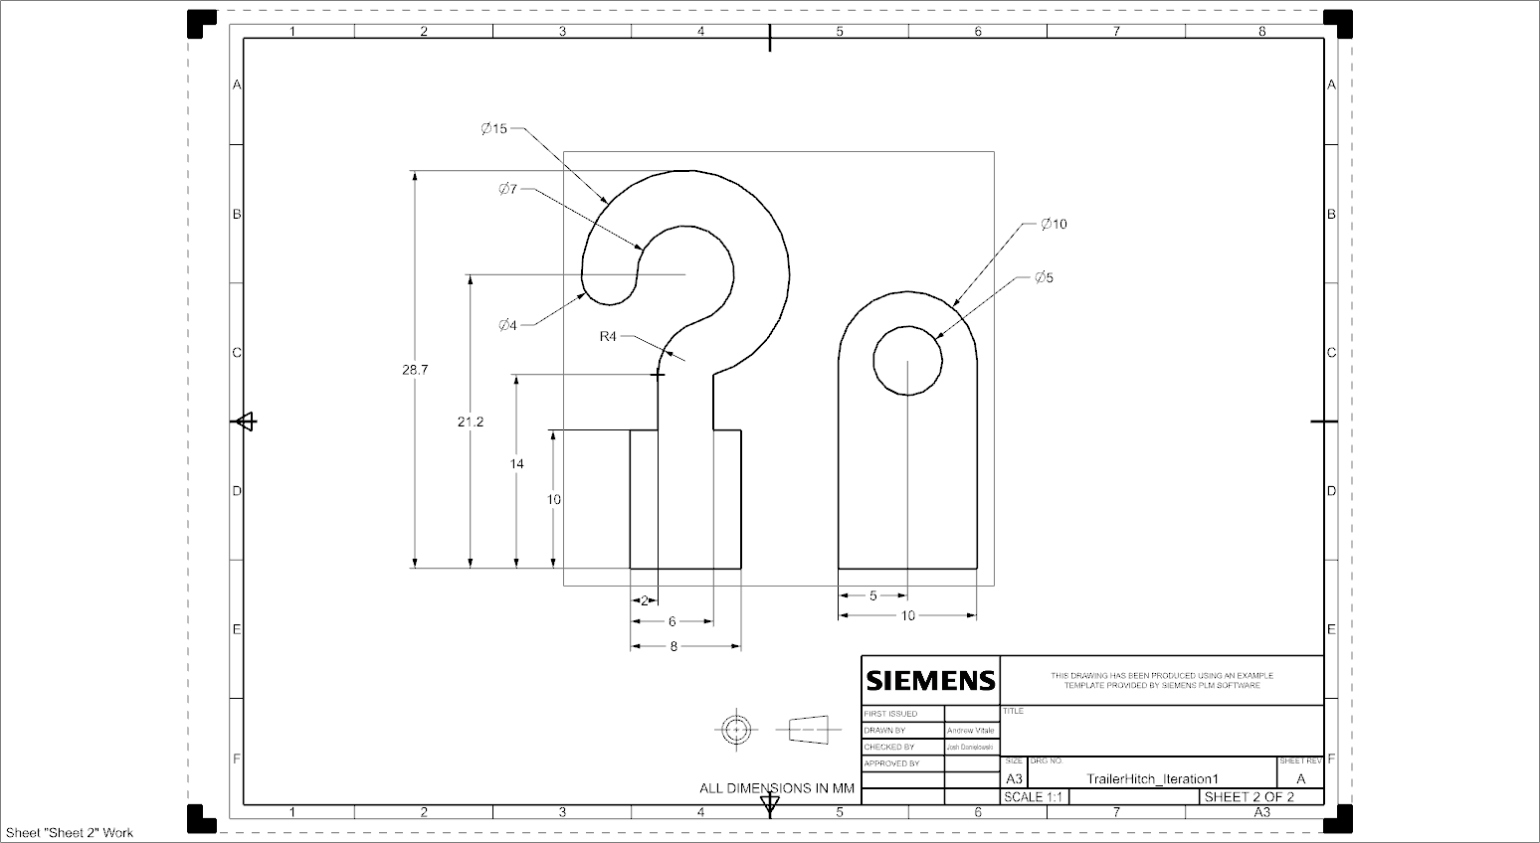

Figure 19: Engineering Drawing for Hitch

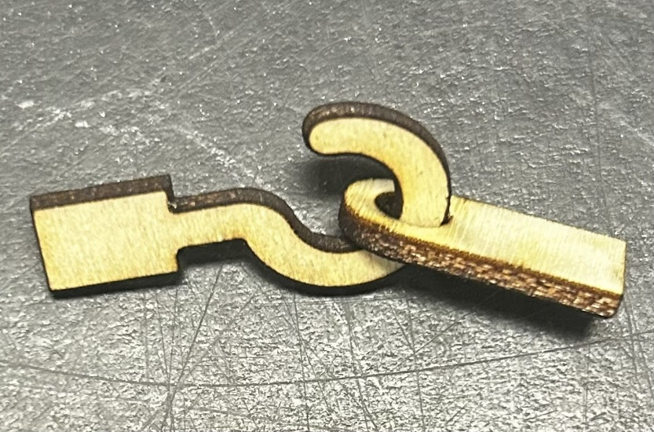

Figure 20: Hitch Prototype 1

## Bill of Materials

The bill of materials for design iteration one, shown in Table 12, lists the different components used to construct the team’s first prototype. The team decided to use a mix of cardboard and basswood sheets to construct the first prototype, as those were the easiest to fit together using two-dimensional shapes cut from the laser cutter to build the three-dimensional geometries that represent the concepts generated by the team. The size for each component was determined using the sum of the areas of each two-dimensional shape. These areas were calculated using the frame dimensions determined by the laser cutter, so the scrap material is included in our calculations for cost, since those scrap pieces are no longer useful for manufacturing other parts. The cost per square millimeter was calculated by dividing the total area of the product per pack of material by the total cost of the pack of material, including a 6% sales tax. The materials used for design iteration one were meant to test the size and fit of parts to the truck chassis and will not be used in future iterations. Since all of the materials and the RC truck were provided to the team, the total cost for the first prototype was $0.

Table 12: Bill of Materials for Design Iteration 1

# Manufacturing and Assembly Plan

For each subsystem: polymer body, tires, Trine “T”, bumper, trailer, and hitch, a manufacturing plan was created. This was done by creating flowcharts which organize the tasks necessary in chronological order and serve as a tool to follow the team’s progress. Various shapes were used throughout the flowcharts, which represent distinct steps in the manufacturing process. The shape’s function and description are found below in Table 13.

Table 13: Legend for Manufacturing Flowcharts

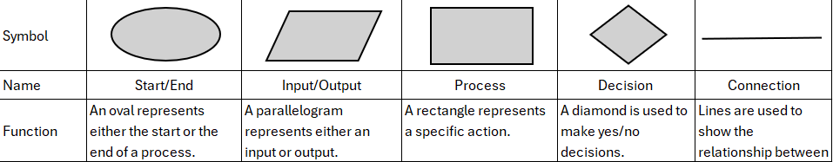

## Polymer Body

The manufacturing plan for the polymer body is displayed in Figure 21. Due to the limitations of the first design iteration, the team simplified the CAD for the polymer body into several 2D geometries. The team created a side profile for the body, which was laser-cut twice along with six rectangles of specific dimensions to form the top of the body and connect the two side profiles. The team cut two identical trapezoids and a rectangle, which were assembled to replicate a spoiler. All of these pieces were glued together and placed on the RC truck to verify the correct dimensions. After analyzing the complete cardboard body, the team concluded that the next design iteration would need to be thinner and slightly shorter, with the wheel wells being smaller. These issues will be addressed in design iteration two.

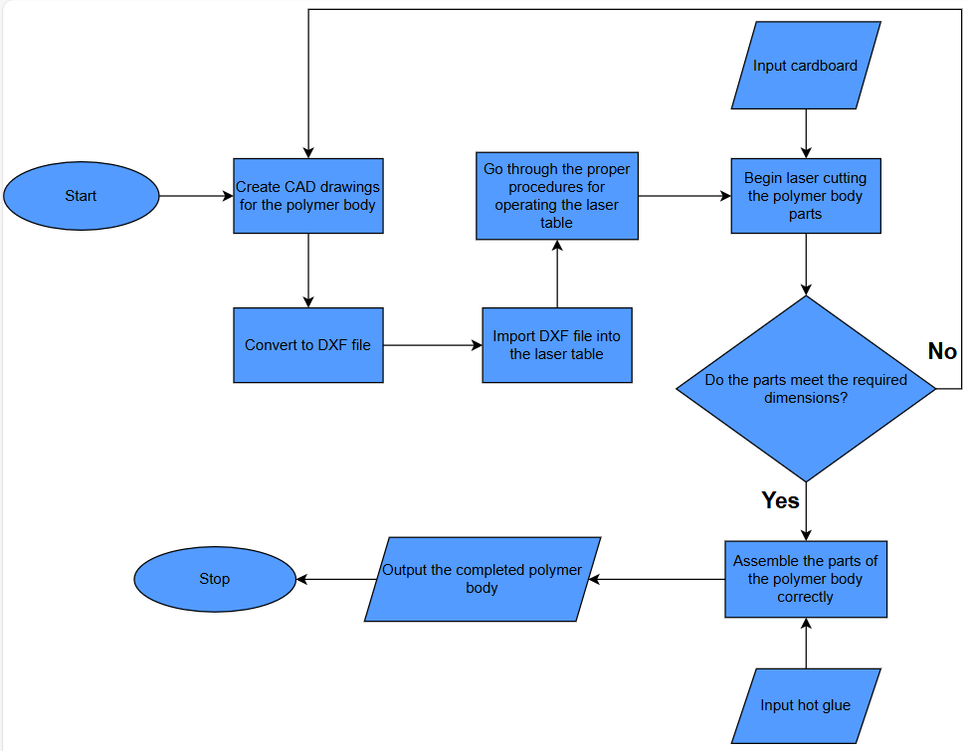

Figure 21: Manufacturing Flow Chart for Body

## Tires

The manufacturing plan for the tires is shown in Figure 22. To test the fitment of the tire to the axle, the team produced a single tire part. This was done by making a simple tire-shaped CAD drawing and laser cutting it out of basswood. This part was placed on the axle of the RC truck and its diameter was compared to the existing tires. After analyzing the fit, the team concluded that the part meets the dimensional requirements and fits well on the existing chassis.

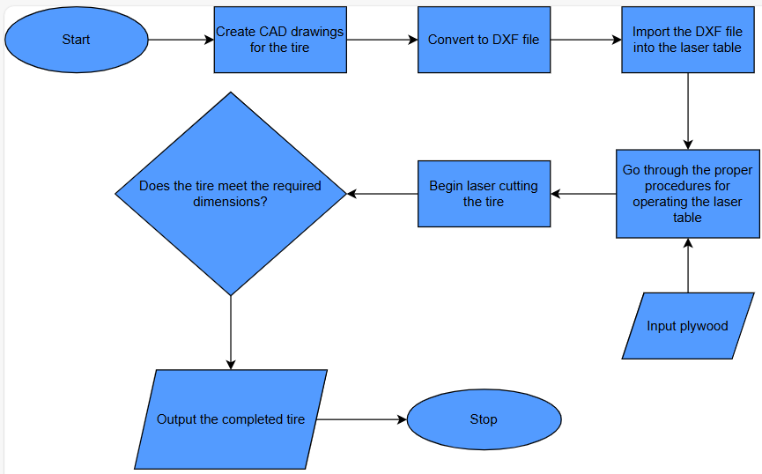

Figure 22: Manufacturing Flow Chart for Tire

## Trine “Power T”

The manufacturing plan for the Trine “Power T”, which will be used to display school pride, is shown in Figure 23. First, the logo was drawn in CAD and cut out of cardboard using the laser cutter. The dimensions of the Trine “Power T” allow for it to be easily attached to the top of the polymer body, without affecting the RC truck’s performance. After placing the finished part on the roof, the team concluded that the dimensions were sufficient.

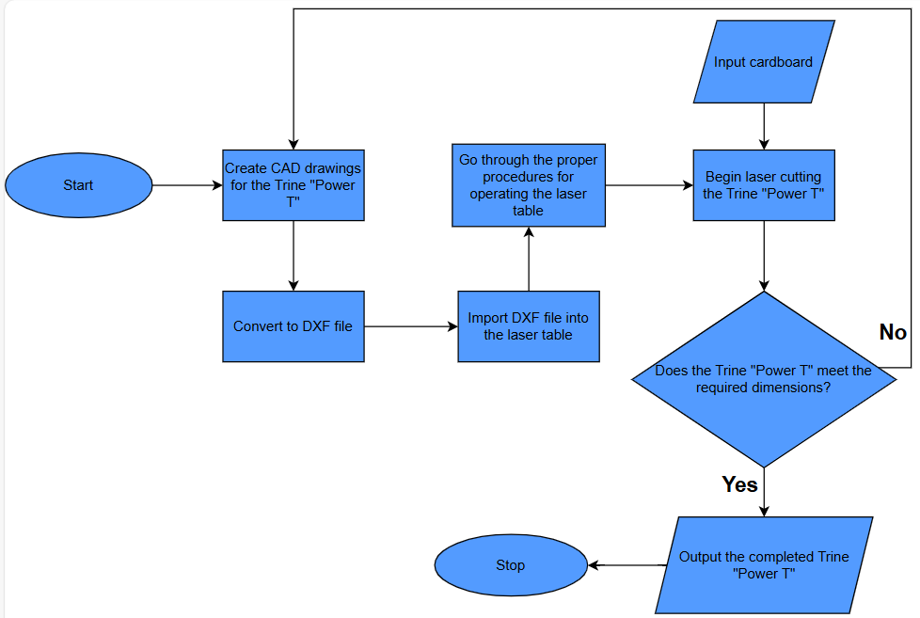

Figure 23: Manufacturing Flow Chart for Power T

## Bumper

The manufacturing plan for the bumper is displayed in Figure 24. First, the bumper was drawn in CAD and then laser-cut out of basswood. This iteration of the bumper was designed to verify the dimensions of a bumper that can be successfully screwed into the rear of the RC truck in the same manner as the original part. It consists of a base with four holes, which allows for the bumper to be easily attached to the RC truck, and a rectangular section with another rectangle cut out of it, which makes up the actual bumper. This design choice reduces the bumper's mass while ensuring successful attachment and proper dimensional accuracy. After assembling the part, the team concluded that it meets the given requirements.

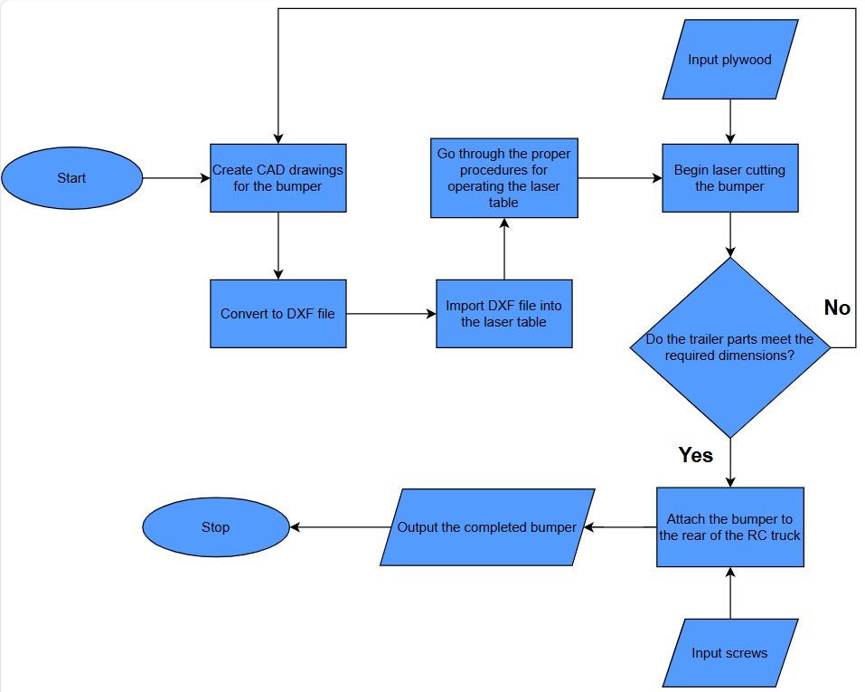

Figure 24: Manufacturing Flow Chart for Bumper

## Trailer

The manufacturing plan for the trailer is displayed in Figure 25. Similar to bumper, the trailer was drawn in CAD and laser-cut out of cardboard. Due to the constraints of using only the laser table for the first design iteration, the team created CAD drawings of rectangles with the specified dimensions, which were then cut and then glued together. This provided a strong baseline for the dimensions of the trailer, which this iteration is focused on nailing. After analysis of the trailer, it was determined that the dimensions of an ideal trailer were successfully replicated.

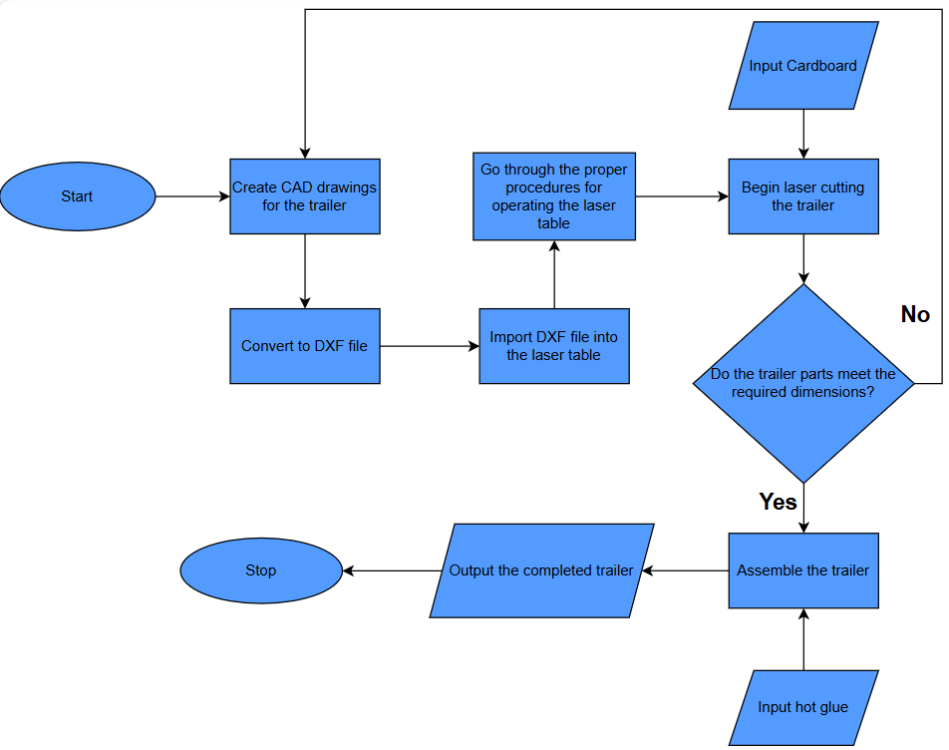

Figure 25: Manufacturing Flow Chart for Trailer

## Hitch

The manufacturing plan for the hitch is displayed in Figure 26. The limitations presented for the first design iteration forced the team to take a new approach to the hitch. These constraints made it difficult to produce the two sections of the hitch already attached to the bumper and trailer. As a solution, the team produced the hitch as a separate 2D model. This allowed for an accurate assessment of the dimensions of the hitch while still adhering to the limitations of the first iteration. The team determined that the hitch produced met the dimensional requirements.

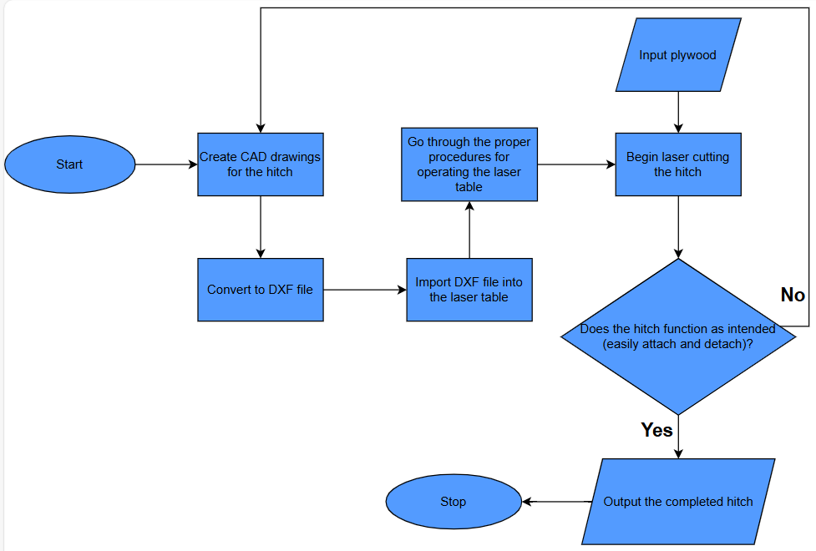

Figure 26: Manufacturing Flow Chart for Hitch

# Testing and Validation (Design Iteration 1)

For this design iteration, the team chose six criteria: body dimensions, tire outer diameter and connection, Hitch connection, Trine pride, bumper width, and trailer dimensions. Table 14 lists the team’s requirements, reasonings, expected and actual outcomes, and a pass or fail rating based on the actual outcome. The body of the car was slightly larger than expected given our measurements, with the wheel wells not centered on the wheels. The cardboard body was loosely fitted to the chassis of the RC car to test fitment and clearance.

The tires were made from basswood, and the outer diameter was made to be roughly the same size as the actual tires on the RC car and to verify the mounting holes would fit the axle. After comparing the tire to the existing RC truck tire, the team concluded that the tire diameter was sufficient. In addition, when the tire was placed on the axle, the team concluded that the dimensions of the hexagon cutout for the axle were correct, and that the wheel would fit well on the axle without slipping.

The hitch connection was also made from basswood, and the dimensions were developed by the team with a thickness that would support the weight of the load while ensuring that the trailer stayed connected to the truck. The first iteration was to test the dimensions of the connection, and after producing the part and assessing the fit, the team decided to move forward with those dimensions for future design iterations.

The Power T was cut out of a piece of cardboard and mounted to the top of the car body. After comparing the dimensions to that of the roof of the body, the team concluded that it was a good fit for the roof of the car, and that the team will proceed with those dimensions for design iteration two.

The bumper was made from cardstock first, to test if the mounting holes lined up and the tolerances were correct. The bumper was then made from basswood and glued together to make sure the bumper did not interfere with the wheels or axles. The trailer was laser cut from five pieces of cardboard and glued together with hot glue. This was to test the overall size of the trailer and the bed area. After testing, the team concluded that both the bumper and trailer met the expected outcome and would move forward with those dimensions for future design iterations.

Table 14: Testing and Validation for Design Iteration 1

|  |  |  |  |  |
| --- | --- | --- | --- | --- |
| **Requirement** | **Reason** | **Expected Outcome** | **Actual Outcome** | **Pass/Fail** |
| Body Dimensions | Must fit the RC truck which had an original shell with the dimensions 24 x 11 x 8 cm. | 240 x 110 x 80 mm | 255 x 110 x 80 mm | Fail |
| Tire Outer Diameter/Hexagon Connection | Must have dimensions similar to the truck's original tires to properly fit existing chassis | do = 80-90 mm/w =12 mm | 88 mm/12.1 mm | Pass |
| Hitch Connection | To ensure that the hook fits the loop connection point on the bumper. | Hook secure in loop, fit easily | Yes | Pass |
| Trine Pride | To proudly represent the school of our team members. | Appearance of Trine "Power T" | Yes | Pass |
| Bumper Width | To ensure the bumper fits onto the RC truck properly. | 90 mm | 90 mm | Pass |
| Trailer Dimensions | So that the trailer is proportional to the RC truck and can handle the designated load. | At least 140 x 80 x 40 mm | 180 x 100 x 50 mm | Pass |

# References

Jain, M., Kumar, D., Chaudhary, J., Kumar, S., Sharma, S., & Verma, A. S. (2023). Review on E-waste management and its impact on the environment and society. *Waste Management Bulletin*, *1*(3), 34–44. https://doi.org/10.1016/j.wmb.2023.06.004

Liu, A. F. (2005). Mechanical Properties Data for Selected Aluminum Alloys. *Mechanics and Mechanisms of Fracture: An Introduction*. https://doi.org/10.1361/memf2005p397

Research and Markets. (2024, October). *Remote Control Toy Car Market Size, Share & Forecast to 2030*. Researchandmarkets.com. https://www.researchandmarkets.com/report/remote-control-car?srsltid=AfmBOorspPPrs02NN1OJe69PnbJXkOD7tWMMbDkqbp_mCr7CasW37FTq